New Patient Surgery Intake Checklist
The following must be completed prior to scheduling an initial consult. Once complete, please send to the Transgender Care Navigator by email to TransCare@ucsf.edu or by fax to 415-353-3399. Please include your full legal name and date of birth when sending this form back. If you have questions, please call 415-885-7770 or visit transcare.ucsf.edu

Referral Requirements Letters

Obtain 1 letter from your medical provider (must be an MD, NP, or PA). The letter should follow the format described at: transcare.ucsf.edu/file/426

Obtain 1 referral letter from your licensed mental health provider. Details of the required assessment process and referral letter requirements can be found here: transcare.ucsf.edu/surgery-referral-assessment-requirements
- For those with no access to a mental health provider able to perform this assessment, our mental health staff can provide this for you
- 2 referral letters, from 2 separate licensed mental health providers, are required for: orchiectomy, hysterectomy, oopherectomy

Additional medical requirements for chest surgeries only
Documented body mass index (BMI) < 35
- This can be included in medical records from a recent doctor visit or in your medical clearance letter (see below)
For patients seeking masculinizing chest surgery who are over the age of 40, a mammogram within past year
For patients seeking breast augmentation, a documentation of current and consistent estrogen therapy for a minimum of 12 months

Insurance Information
Name of Insurance Company:
Insurance Member ID Number:
Insurance Phone Number for Providers/Billing:
Please check with your insurance if UCSF Medical Center, Plastics & Reconstructive Surgery is considered in-network with your plan.
- If not in-network, you need to check if your plan has out of network benefits, and obtain authorization for out-of-network care
Please check with your insurance if a referral & authorization are needed from your primary care provider (PCP) for a specialist consultation with the surgeon.
- If yes, ask your primary care provider to send the referral to UCSF Plastic and Reconstructive Surgery; CPT codes for office visit consultation: 99244 and 99245

Please check with your insurance plan if a referral and authorization are required for a specialist consultation with a surgeon. Please note that each surgery needs its own referral and/or authorization. See below for specific department and CPT codes needed.

SURGERY | DEPARTMENT | CPT CODES (# of visits)
Top surgery | UCSF Plastic and Reconstructive Surgery | 99244 (1), 99245 (1)
Facial Feminization Surgery | UCSF Plastic and Reconstructive Surgery or UCSF Facial Plastic Surgery | 99245 (1)
Orchiectomy | UCSF Urology Faculty Practice | 99204 (1)
Hysterectomy and Oophorectomy | UCSF Department of Obsetrics, Gynecology and Reproductive Sciences | 99204 (1)

After your initial consultation, the doctor will recommend specific procedures. At that time, you can meet with the staff and check your insurance for those specific procedures.

UCSF Transgender Care Patient Intake Packet
Today’s Date: ____________
Chosen Name:
Legal Name (if different):
Chosen Pronouns:
Date of Birth: _______________
Gender Identity:
Birth Assigned Sex: Female Male
Do you require a translator? Yes Language:
No

Current employment status (check all that apply):
☐Full time work ☐Part time work ☐Student ☐Unemployed, looking for work
☐Unemployed, not looking for work ☐Currently on disability

Marital status
☐Single, never married ☐Married/domestic partner ☐Partnered but not legally married
☐Separated/divorced ☐Widowed

Highest level of education completed:
☐Some high school ☐High school diploma ☐Some college ☐Vocational degree/technical school
☐Associates degree ☐Bachelor’s degree ☐Masters degree ☐Doctoral Degree

Place of work / name of school

Please list any sources of additional financial support

Who lives with you?

How long have you lived there?

Do you have a private room?

Do you have access to a shower?

Do you have any possible upcoming changes in your housing? If so, describe:

Do you have any financial issues which may threaten your housing? If so, please describe:

Do you have a car?
If you do not have a car, how do you get around?

Who is going to take you to and from your surgery appointment?

Who is going to stay with you after surgery?

Who is available to help you with the following possible scenarios after surgery (name person/s for each individual scenario):
Need to go to the emergency room

Need to go back to see my surgeon for a visit

Need to go to the pharmacy for medications or supplies

Need to go to the store to buy food or help me prepare food at home?

What is the name of the nearest hospital emergency room to where you live?

Do you have a local primary care provider where you live? Yes ☐ No☐
If yes, Primary Provider Name
Phone #

For each of the questions below, please indicate the difficulty of each activity by using the following key and circling the most appropriate number:

0 = No Difficulty
1 = Mild Difficulty
2 = Moderate Difficulty
3 = Severe Difficulty
4 = Extreme Difficulty or Cannot Do
Standing for long periods such as 30 minutes?
0 1 2 3 4
Taking care of your household responsibilities?
0 1 2 3 4
Learning a new task, for example, learning how to get to a new place?
0 1 2 3 4
Joining in community activities (for example, festivities, religious or other activities) in the same way as anyone else can?
0 1 2 3 4
How much have you been emotionally affected by your health problems?
0 1 2 3 4
Concentrating on doing something for ten minutes?
0 1 2 3 4
Walking a long distance such as a ½ mile?
0 1 2 3 4
Washing your whole body?
0 1 2 3 4
Getting dressed?
0 1 2 3 4
Dealing with people you do not know?
0 1 2 3 4
Maintaining a friendship?
0 1 2 3 4
Your day-to-day work/school?
0 1 2 3 4

Overall, in the past 30 days, how many days were these difficulties present?
In the past 30 days, for how many days were you totally unable to carry out your usual activities or work because of any health condition?

In the past 30 days, not counting the days that you were totally unable, for how many days did you cut back or reduce your usual activities or work because of any health condition?

Please review this label from a container of ice cream, and answer the following questions. This is not a test! How well you answer the questions will not have any impact on your ability to have surgery. This is only to allow us to better understand how to help you read and follow wound care instructions, prescriptions, etc.:
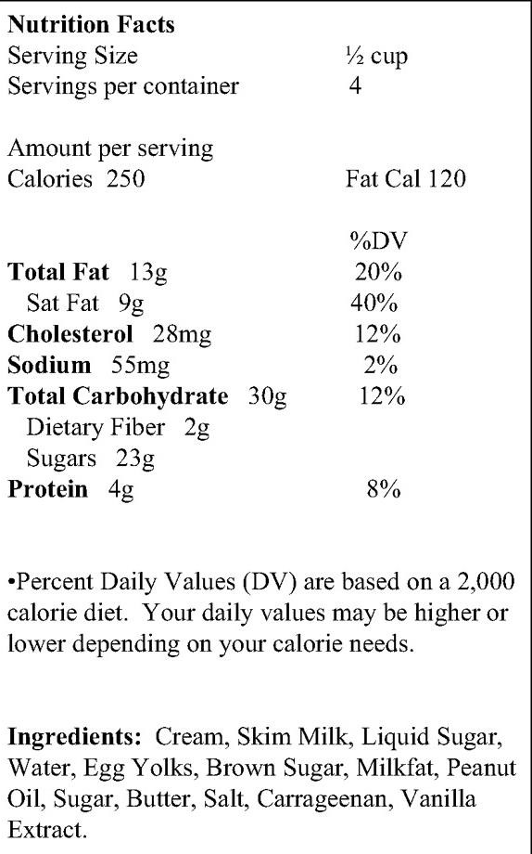
If you eat the entire container, how many calories will you eat?

If you are allowed to eat 60 g of carbohydrates as a snack, how much ice cream could you have?

How much ice cream would that be if measured into a bowl?

Your doctor advises you to reduce the amount of saturated fat in your diet. You usually have 42 grams of saturated fat each day, which includes 1 serving of ice cream. If you stopped eating ice cream, how many grams of saturated fat would you be consuming each day?

If you usually eat 2,500 calories in a day, what percentage of your daily value of calories will you be eating if you eat one serving?

Pretend you are allergic to the following substances: Penicillin, peanuts, latex gloves, and bee stings. Is it safe for you to eat this ice cream?
Why or why not?

