UCSF Gender Affirming Health Program

Social Work Intake Packet
Today’s Date: ____________
Chosen Name:
Legal Name (if different):
Chosen Pronouns:
Date of Birth: _______________
Gender Identity:
Birth Assigned Sex: Female Male
Do you require a translator? Yes Language:
No

Current employment status (check all that apply):
☐Full time work ☐Part time work ☐Student ☐Unemployed, looking for work
☐Unemployed, not looking for work ☐Currently on disability

Marital status
☐Single, never married ☐Married/domestic partner ☐Partnered but not legally married
☐Separated/divorced ☐Widowed

Highest level of education completed:
☐Some high school ☐High school diploma ☐Some college ☐Vocational degree/technical school
☐Associates degree ☐Bachelor’s degree ☐Masters degree ☐Doctoral Degree

Place of work / name of school

Please list any sources of additional financial support

Who lives with you?

How long have you lived there?

Do you have a private room?

Do you have access to a shower?

Do you have any possible upcoming changes in your housing? If so, describe:

Do you have any financial issues which may threaten your housing? If so, please describe:

Do you have a car?
If you do not have a car, how do you get around?

Who is going to take you to and from your surgery appointment?

Who is going to stay with you after surgery?

Who is available to help you with the following possible scenarios after surgery (name person/s for each individual scenario):
Need to go to the emergency room

Need to go back to see my surgeon for a visit

Need to go to the pharmacy for medications or supplies

Need to go to the store to buy food or help me prepare food at home?

What is the name of the nearest hospital emergency room to where you live?

Do you have a local primary care provider where you live? Yes ☐ No☐
If yes, Primary Provider Name
Phone #

For each of the questions below, please indicate the difficulty of each activity by using the following key and circling the most appropriate number:

0 = No Difficulty
1 = Mild Difficulty
2 = Moderate Difficulty
3 = Severe Difficulty
4 = Extreme Difficulty or Cannot Do
Standing for long periods such as 30 minutes?
0 1 2 3 4
Taking care of your household responsibilities?
0 1 2 3 4
Learning a new task, for example, learning how to get to a new place?
0 1 2 3 4
Joining in community activities (for example, festivities, religious or other activities) in the same way as anyone else can?
0 1 2 3 4
How much have you been emotionally affected by your health problems?
0 1 2 3 4
Concentrating on doing something for ten minutes?
0 1 2 3 4
Walking a long distance such as a ½ mile?
0 1 2 3 4
Washing your whole body?
0 1 2 3 4
Getting dressed?
0 1 2 3 4
Dealing with people you do not know?
0 1 2 3 4
Maintaining a friendship?
0 1 2 3 4
Your day-to-day work/school?
0 1 2 3 4

Overall, in the past 30 days, how many days were these difficulties present?
In the past 30 days, for how many days were you totally unable to carry out your usual activities or work because of any health condition?

In the past 30 days, not counting the days that you were totally unable, for how many days did you cut back or reduce your usual activities or work because of any health condition?

Please review this label from a container of ice cream, and answer the following questions. This is not a test! How well you answer the questions will not have any impact on your ability to have surgery. This is only to allow us to better understand how to help you read and follow wound care instructions, prescriptions, etc.:
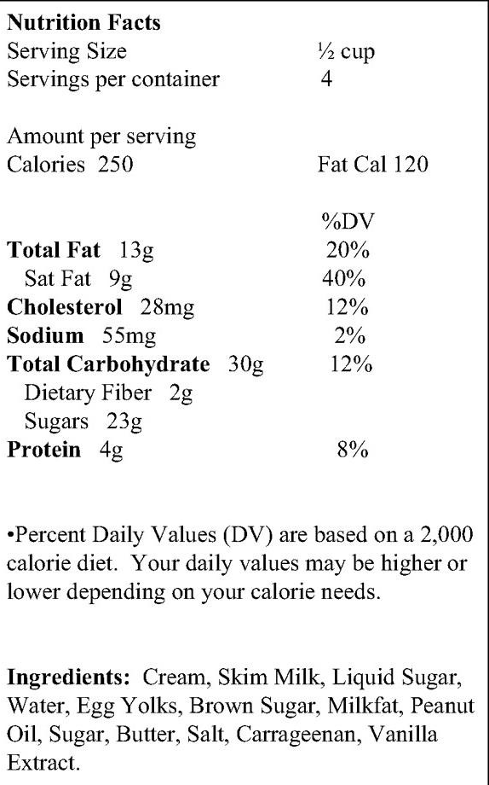
If you eat the entire container, how many calories will you eat?

If you are allowed to eat 60 g of carbohydrates as a snack, how much ice cream could you have?

How much ice cream would that be if measured into a bowl?

Your doctor advises you to reduce the amount of saturated fat in your diet. You usually have 42 grams of saturated fat each day, which includes 1 serving of ice cream. If you stopped eating ice cream, how many grams of saturated fat would you be consuming each day?

If you usually eat 2,500 calories in a day, what percentage of your daily value of calories will you be eating if you eat one serving?

Pretend you are allergic to the following substances: Penicillin, peanuts, latex gloves, and bee stings. Is it safe for you to eat this ice cream?
Why or why not?

